# Applying for a team account with credit code redemption

Create a Team AWS Account

1. Head to link below to set up the shared team account: <https://portal.aws.amazon.com/billing/signup?redirect_url=https%3A%2F%2Faws.amazon.com%2Fregistration-confirmation#/start>
2. 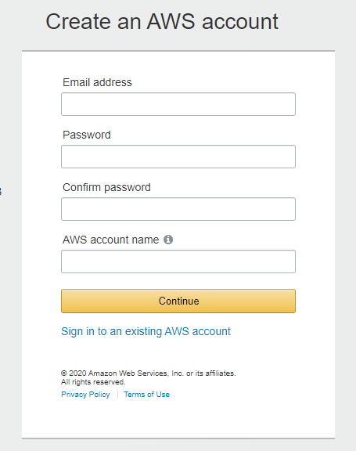Enter your account information, and then choose Continue. Be sure that you enter your account information correctly, especially your email address. If you enter your email address incorrectly, you can't access your account.
3. 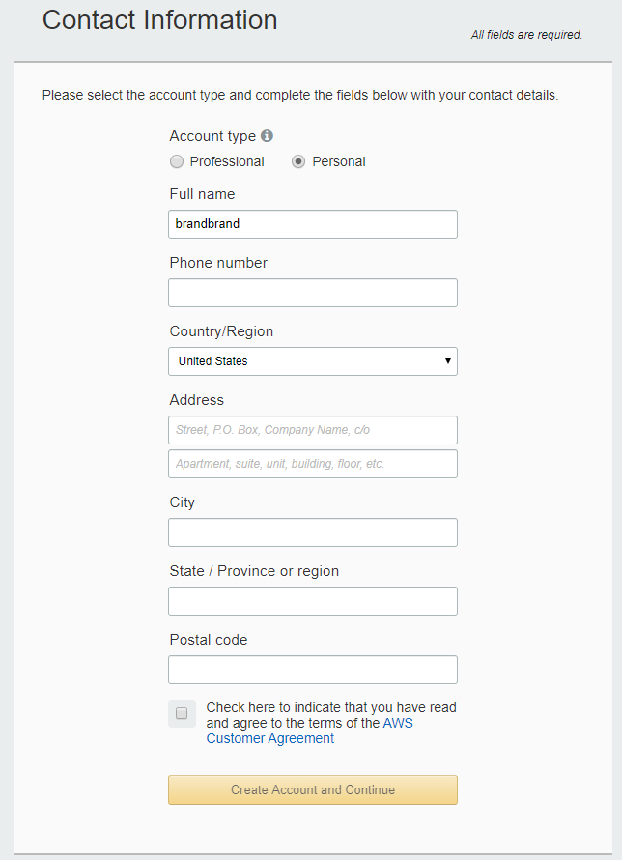Select **Personal** and enter the relevant information.
4. 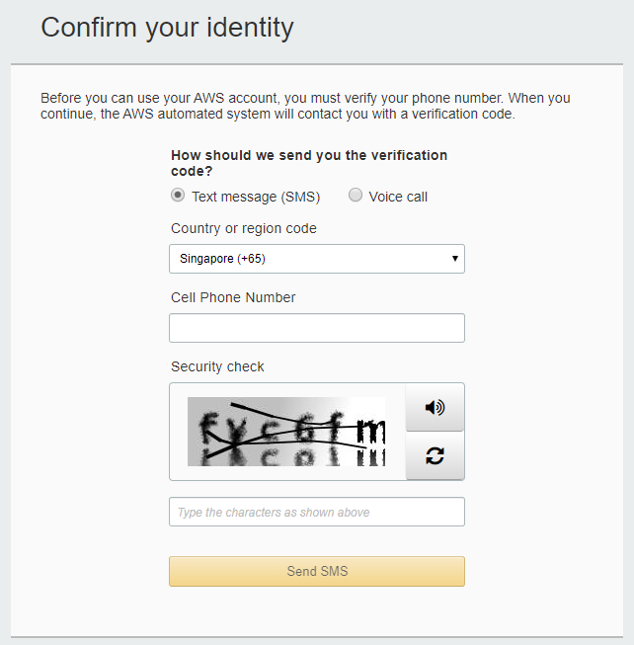Complete the registration by providing a valid payment method and confirming your phone number.
5. 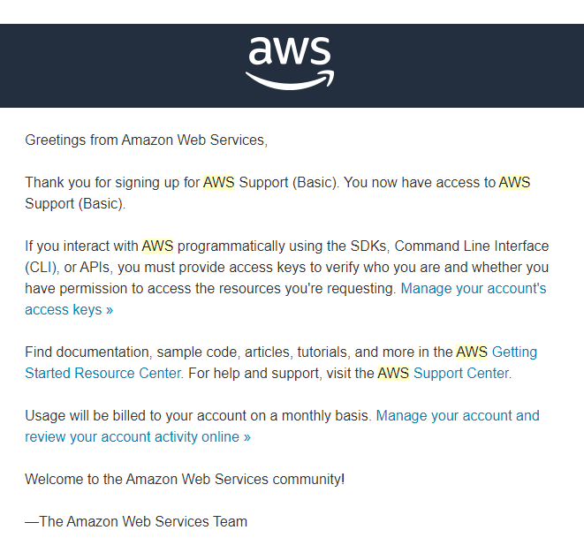At the AWS Main Console top navigation bar, go to **My Billing Dashboard**.

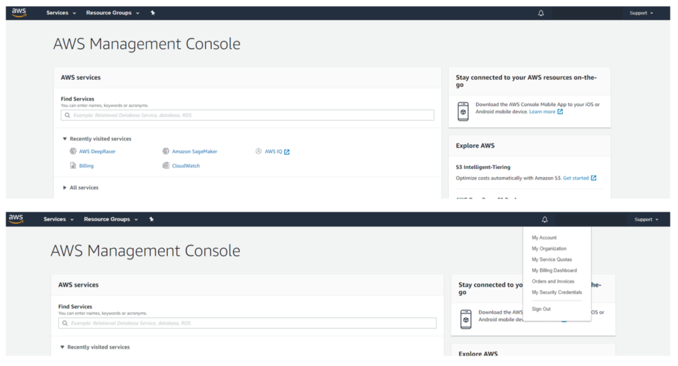

1. At the sidebar, click on **credits**.

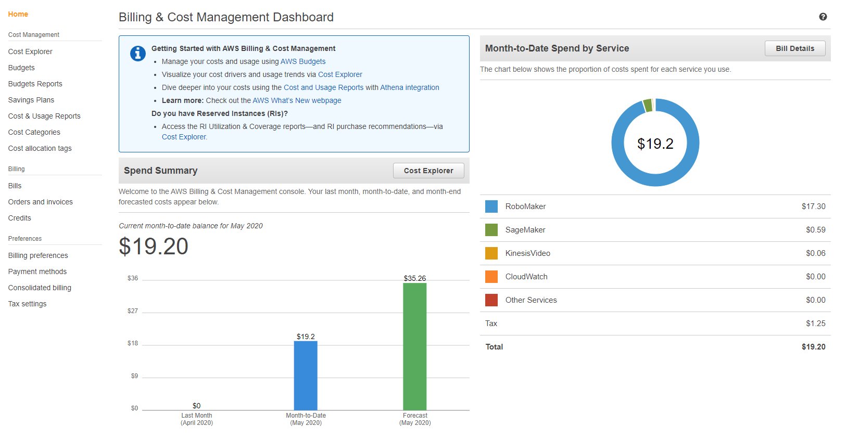

1. 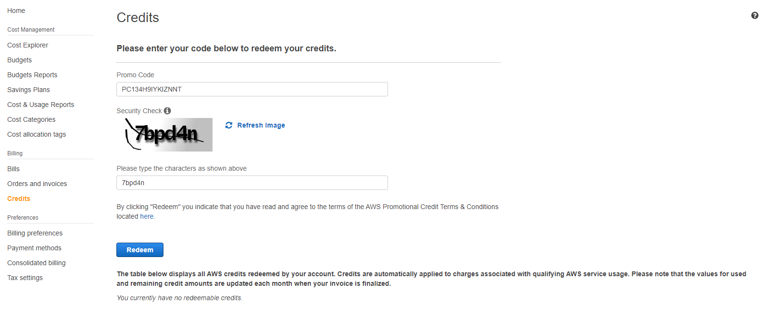Enter the promo code given and the security characters as shown. The promo code had been sent to the team email between 5th to 6th June 2020.
2. 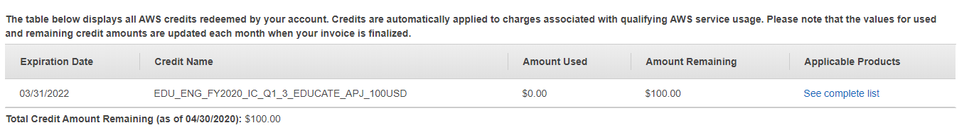Redemption should be immediate and the redeemed credits should reflect at the bottom of the page.

# Applying for an AWS Educate Student/Starter Account

1. Go to the URL: <https://bit.ly/3bs4ubS>

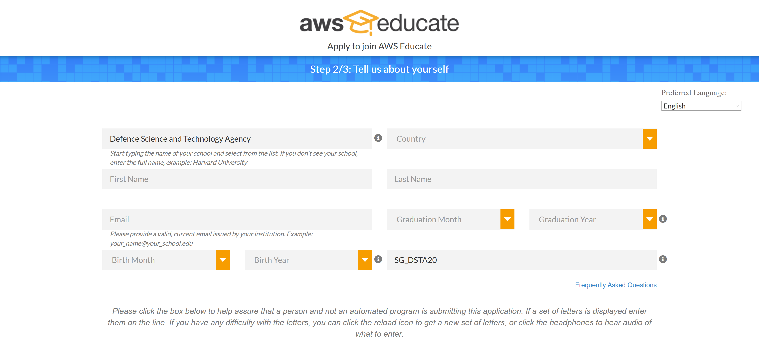

1. Ensure that the SCHOOL/INSTITUTION NAME field is set to “Defence Science and Technology Agency”, with the PROMO CODE field set to SG_DSTA20.



1. Fill out the form with the relevant information and submit the application.
2. Verify your email address via the email that is sent to your inbox. After which an email will inform you that your application is under review and to wait for the approval email.

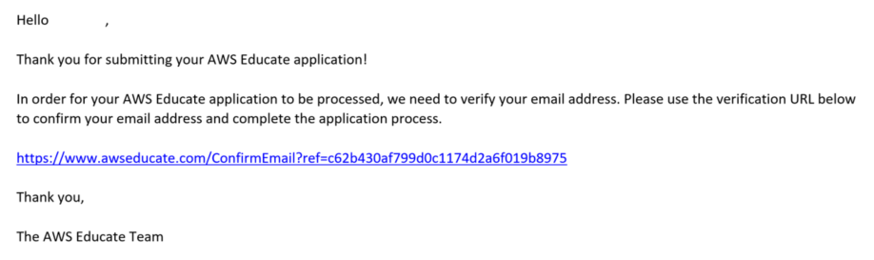

1. Upon approval, click the link to finish setting up your AWS Educate account.

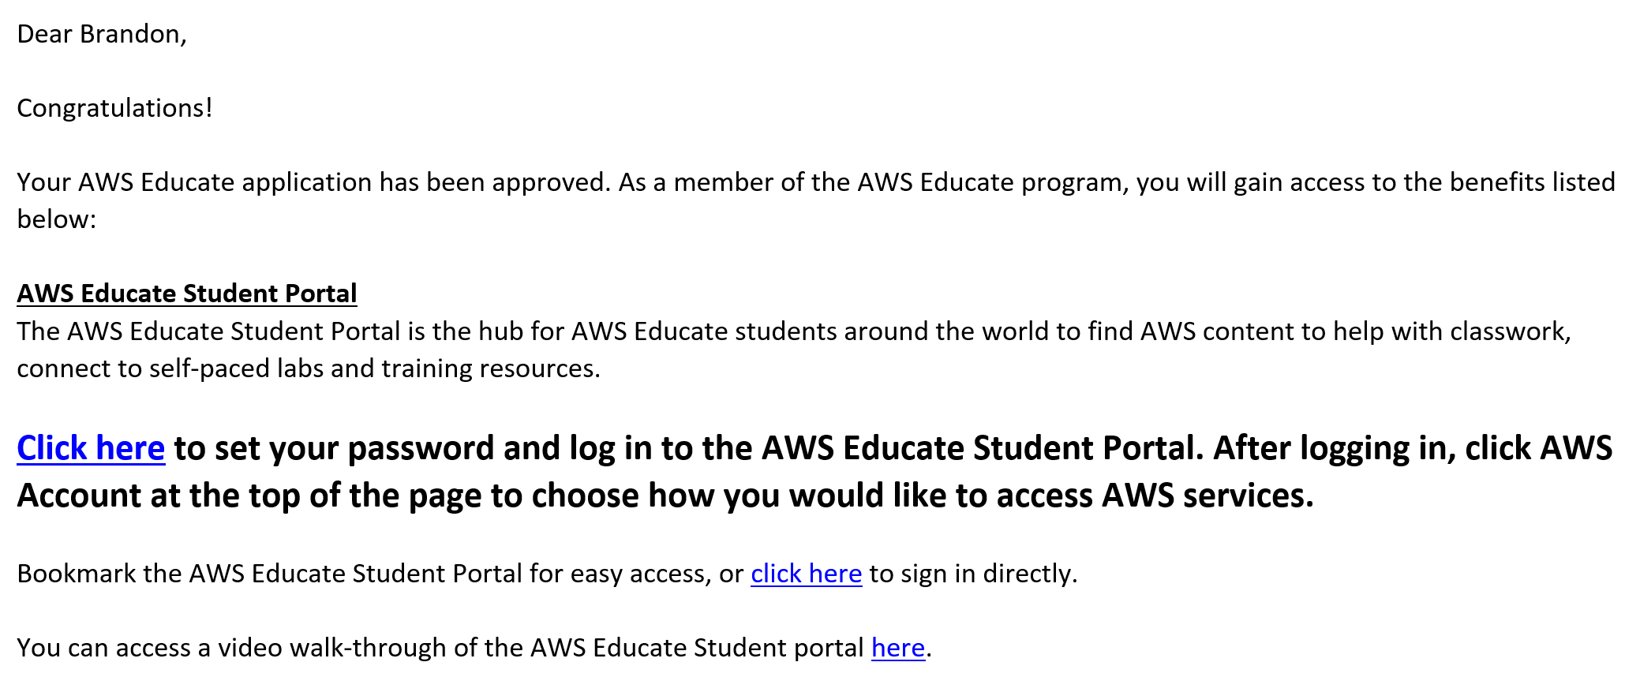

1. Set up your password using the link in the email. Login to your AWS account.

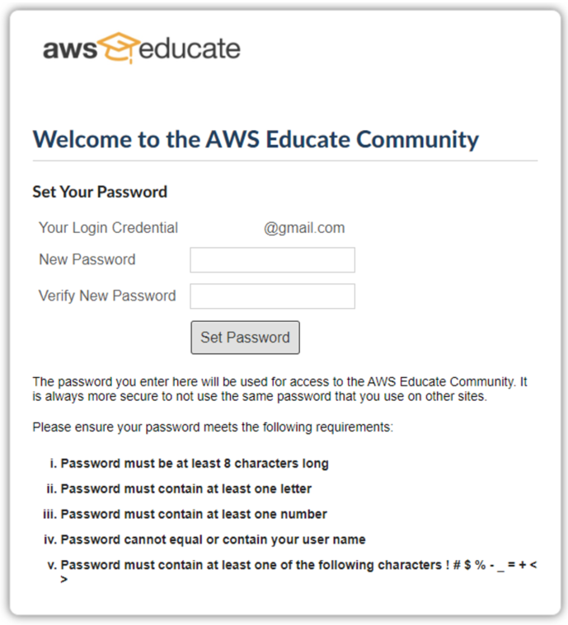

1. Click on **AWS Account** on the top right of the page and click Activate AWS Account.



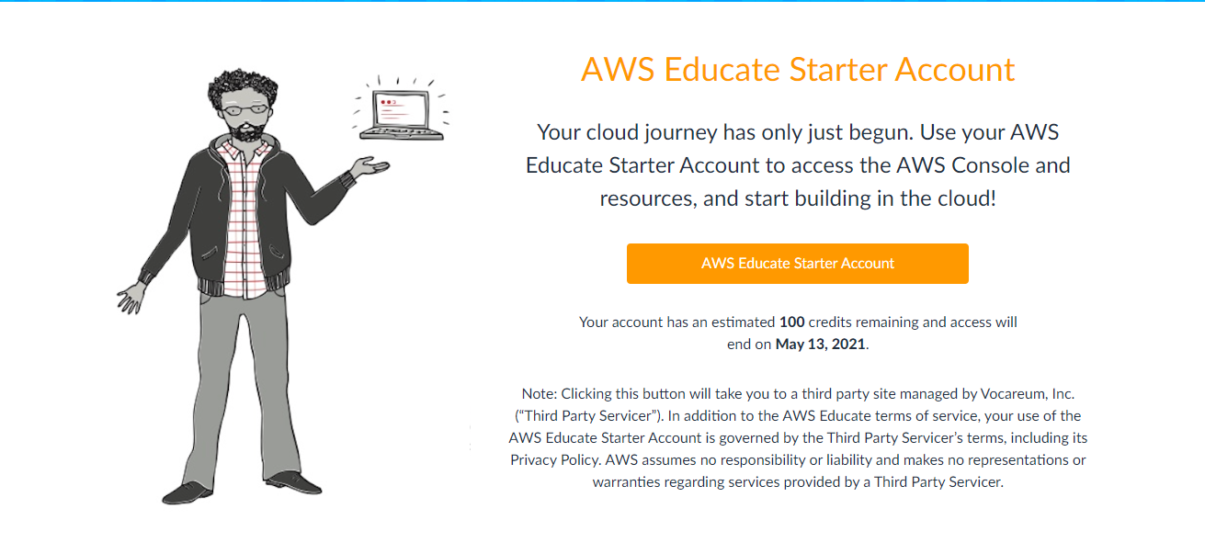

1. Click on **AWS console** to access the AWS Management Console and services.

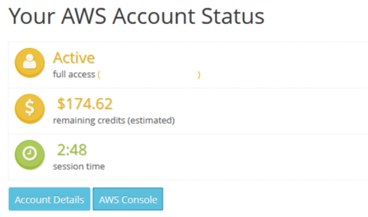

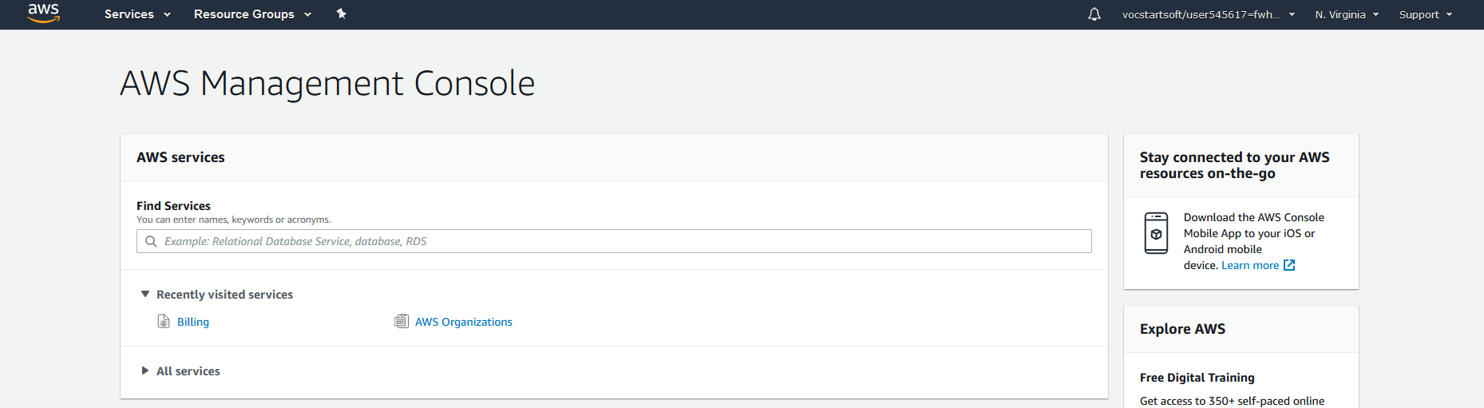

1. Note: The credit code given to your team should be used with the team account, and it will not work with this AWS Educate Starter/Student account as it cannot use promotional codes. There are restrictions with the Educate account which you can find here: <https://awseducate-starter-account-services.s3.amazonaws.com/AWS_Educate_Starter_Account_Services_Supported.pdf>